# **JOKKMOKK Table and 4 chairs,**

# **antique stain**

**Product details $999**

Easy to bring home since the whole dining set is packed in one box.

Read More

**Materials & care**

Solid pine, Stain, Clear acrylic lacquer

Wipe clean with a mild soapy solution. Wipe dry with a clean cloth. For maximum quality, re-tighten the screws when necessary.

## Product size

**Table length:**

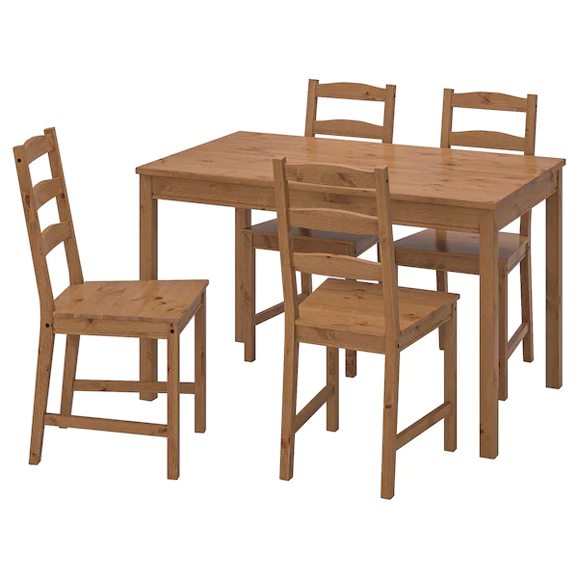118 cm (46 1/2 ")

**Table width:**

74 cm (29 1/8 ")

**Table height:**

74 cm (29 1/8 ")

**Seat width:**

41 cm (16 1/8 ")

**Seat depth:**

41 cm (16 1/8 ")

**Seat height:**

44 cm (17 3/8 ")